*Florida International University*

*School of Computing and Information Sciences*

Software Engineering Focus

Final Deliverable

Project Title:

Apps, Arts and Issues: APP-lying the Arts to Digital Communication

**Team Members:** Claudia Gourdet, Ramses Melo, Jose Ayala, Derek Hernandez, Enrique Hidalgo, Mariel Juarez, Nathalie Llaneza

**Product Owner(s)**: Dr. Steve Rios

**Mentor(s)**: Prof. Margo Berman, Prof. Francisco Ortega

**Instructor**: Masoud Sadjadi

The MIT License (MIT)

Copyright (c) *2016 Florida International University*

Permission is hereby granted, free of charge, to any person obtaining a copy of this software and associated documentation files (the "Software"), to deal in the Software without restriction, including without limitation the rights to use, copy, modify, merge, publish, distribute, sublicense, and/or sell copies of the Software, and to permit persons to whom the Software is furnished to do so, subject to the following conditions:

The above copyright notice and this permission notice shall be included in all copies or substantial portions of the Software.

THE SOFTWARE IS PROVIDED "AS IS", WITHOUT WARRANTY OF ANY KIND, EXPRESS OR IMPLIED, INCLUDING BUT NOT LIMITED TO THE WARRANTIES OF MERCHANTABILITY, FITNESS FOR A PARTICULAR PURPOSE AND NONINFRINGEMENT. IN NO EVENT SHALL THE AUTHORS OR COPYRIGHT HOLDERS BE LIABLE FOR ANY CLAIM, DAMAGES OR OTHER LIABILITY, WHETHER IN AN ACTION OF CONTRACT, TORT OR OTHERWISE, ARISING FROM, OUT OF OR IN CONNECTION WITH THE SOFTWARE OR THE USE OR OTHER DEALINGS IN THE SOFTWARE.

***Abstract***

*This document presents the information necessary to gain a good understanding of how cross-disciplinary students at Florida International University Campus utilize Scrum agile methodology for the development of a non-profit organization website. Additionally, they used scrum to guide in the establishment of social media presence and developed campaigns. This Document contains various section that provide an in depth understanding of the user stories completed throughout the sprints, the project plan,system design and system Validation.*

**Table of Contents**

**Introduction** …………………………………………………………………………………………………………………………….. 5

Current System ……….…………………………………………………………………………………………………………... 5

Purpose of New System …………………………………………………..…………………………………………………... 5

**User Stories** …………………………………………………………………………………………………………………………….. 7

Implemented User Stories ………………………………………….………………………………………………………..7

Pending User Stories …………………………………………………………………...………………………………..….. 09

**Project Plan** …………………………………………………………………………………………………………………………….. 10

Hardware and Software Resources ……………………………………………………...……………………….… 10

Sprints Plan ……………………………………………………………..………………………………………………………. 12

*Sprint 1*  …………………………………………………………………………………………………………………………... 12

*Sprint 2*  …………………………………………………………………………………………………………………………... 16

*Sprint 3*  …………………………………………………………………………………………………………………………... 20

*Sprint 4*  …………………………………………………………………………………………………………………………... 24

*Sprint 5*  …………………………………………………………………………………………………………………………... 27

**System Design** ……………………………………………………………………………………………………………………………. 28

Architectural Patterns ………………………………………………………………………………………………….. 29

System and Subsystem Decomposition …………………………………………………………………………….… 29

Deployment Diagram …………………………………………………………………………………………………….…... 30

Design Patterns ………………………………………………………………………………………………………….….... 30

**System Validation**  …………………………………………………………………………………………………………………….32

**Glossary**  ………………………………………………………………………………………………………………………………….34

**Appendix**  ………………………………………………………………………………………………………………………………….35

Appendix A - UML Diagrams ………………………………………………………………………………………………. 35

Appendix B - User Interface Design …………………………………………………………………………….…... 38

Appendix C - Sprint Review Reports …………………………………………………………………………...…… 42

Appendix D - User Manuals, Installation/Maintenance Document, Shortcomings/Wishlist Document and other documents …………………………………………………………………….…………… 46

**References** ……………………………………………………………………………………………………………………...………...47

# 

# Introduction

Positive Pathways which was previously known as Florida Reach is a Department of Children and Families (DCF) program designed to provide services for a network of post-secondary campus-based support initiatives at Florida public colleges, universities and technical / vocational colleges (FL Statute 408.1452).The main goal of Positive Pathways is to increase the number of young adults from foster care who achieve post-secondary education success with the support of dedicated campus-based programs. Positive Pathway program is currently in need of a platform to grow the network for the campus-based support programs , they are unable to effectively communicate amongst members of the network that support the foster care youth. Network members does not have a centralized tool or location to access vital information and resources.

## Current System

Currently Positive Pathway information and links is located on a third party website,Florida Department of Children and Families ( DCF). Network members are unable to directly access information about Positive Pathway without the knowledge of the DCF website link. The DCF website is home of dozens of programs and services through the state of Florida, their webpage contains informations for services such as ACCESS Florida( food stamps and benefits), adult services and child services. In order to locate the Positive Pathway/ Florida Reach information one must search for in sections in an unorganized list. The page that display information is not direct and easily accessible. This process is very ineffective to grow the Positive Pathway Network. As a result, our different teams decided to develop products/solution amongst our three different teams that wo increase collaboration and number of members in the Positive Pathway network so members could better serve foster care youth.

## Purpose of New System

Positive Pathway currently lacks of presence and engagement across social media channels.In order to grow the network to support this population, it is essential to have a strong web presence to recruit members and advocate for Positive Pathway. By understanding the areas of deficiencies, our team develop several solutions. We divided into three teams: graphics, programmers , and communication. The programming team would be responsible to deliver a tool to access information, resources and training ; as well as enhance communication and collaborations amongst the network members. The communication would be responsible for providing media content and establish online presence for client. The graphics team would evaluate, organize and design digital material. By working together we were able to develop effective and valuable solution to support Positive Pathway.

The products that would be delivered by the programming team is a functional website to support the network members that would be accessible on any device and platform. The initial development will focus on providing the tools needed by Network professionals such as an information sharing page, directory with list of members, and calendar component to stay up to date with meetings and events throughout the network. The communication team would would developed social media accounts, such as Facebook , instagram, ..etc. They would also produce campaign images and videos. The graphics team would provide quality images and design campaign graphics that promotes Positive Pathway.

Throughout the completion of this project all teams from our group utilized the Scrum methodology as guidance to develop the deliverables and products. All teams including programmers, graphics and communication participated in the development process over the course of three months. Each team member took on the role from a Scrum Team , from developer's to Scrum Master, UI designers, Product Owner and more; Every team member had responsibilities to upheld throughout the project. By following the Agile methodology we have laid the foundation for this project to continue and for Positive pathway to achieve its mission with the help of cross-disciplinary students at Florida International University.

# 

# User Stories

The following section provides the detailed user stories that were implemented in this iteration of the development phase of the project. These user stories served as the basis for the implementation of the project’s features

The following figures provides a high-level release outline for the Positive Pathway website:

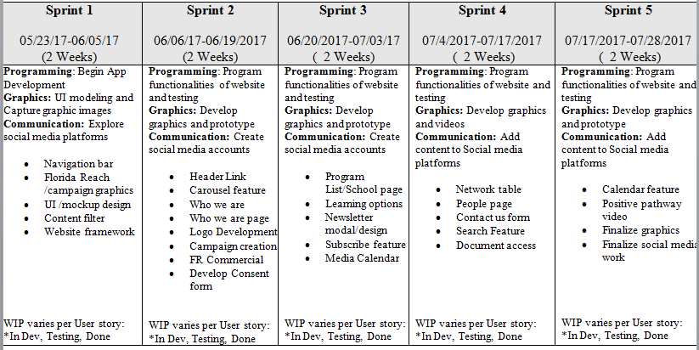

## Implemented User Stories

The following user stories reflects user stories relevant to team project. Not all user story listed are technical due to diverse disciplinaries (Communication and Graphics) that were part of the group; additional user stories that were tasks but did not meet the Agile/scrum user story rubrics are reflected in Mingle.

**Sprint 1:**

# [User Story #677](https://fiu-scis-seniorproject.mingle.thoughtworks.com/projects/apps__arts_and_issues__app_lyi/cards/677) Navigation Bar

# [Story #663](https://fiu-scis-seniorproject.mingle.thoughtworks.com/projects/apps__arts_and_issues__app_lyi/cards/663) Florida Reach STAT- Graphic

# [#667](https://fiu-scis-seniorproject.mingle.thoughtworks.com/projects/apps__arts_and_issues__app_lyi/cards/667) UI / Mockup Design for Florida Reach Mobile Application

**Sprint2:**

# [Story #679](https://fiu-scis-seniorproject.mingle.thoughtworks.com/projects/apps__arts_and_issues__app_lyi/cards/679) Establish Links-Navigation

* [User Story #678](https://fiu-scis-seniorproject.mingle.thoughtworks.com/projects/apps__arts_and_issues__app_lyi/cards/678) Develop Carousel : Home Page

# [User Story #699](https://fiu-scis-seniorproject.mingle.thoughtworks.com/projects/apps__arts_and_issues__app_lyi/cards/699) Develop THINKivator Logo

# [User Story #694](https://fiu-scis-seniorproject.mingle.thoughtworks.com/projects/apps__arts_and_issues__app_lyi/cards/694) Florida Reach Commercial

# [User Story #697](https://fiu-scis-seniorproject.mingle.thoughtworks.com/projects/apps__arts_and_issues__app_lyi/cards/697) Florida Reach Can Help

**Sprint 3:**

# [User Story #682](https://fiu-scis-seniorproject.mingle.thoughtworks.com/projects/apps__arts_and_issues__app_lyi/cards/682) Access Resources

* [#683](https://fiu-scis-seniorproject.mingle.thoughtworks.com/projects/apps__arts_and_issues__app_lyi/cards/683) Programs List for School and Universities

# [#685](https://fiu-scis-seniorproject.mingle.thoughtworks.com/projects/apps__arts_and_issues__app_lyi/cards/685) Learning Options

# [#687](https://fiu-scis-seniorproject.mingle.thoughtworks.com/projects/apps__arts_and_issues__app_lyi/cards/687) Calendar Creation

# [#700](https://fiu-scis-seniorproject.mingle.thoughtworks.com/projects/apps__arts_and_issues__app_lyi/cards/700) Upcoming Events Feature

# [#690](https://fiu-scis-seniorproject.mingle.thoughtworks.com/projects/apps__arts_and_issues__app_lyi/cards/690) Newsletter Module

# [#692](https://fiu-scis-seniorproject.mingle.thoughtworks.com/projects/apps__arts_and_issues__app_lyi/cards/692) Subscribe Opt In/Sign Up

# [#691](https://fiu-scis-seniorproject.mingle.thoughtworks.com/projects/apps__arts_and_issues__app_lyi/cards/691) Social Media Access

**Sprint 4:**

# [#688](https://fiu-scis-seniorproject.mingle.thoughtworks.com/projects/apps__arts_and_issues__app_lyi/cards/688) Documents Access

# [#681](https://fiu-scis-seniorproject.mingle.thoughtworks.com/projects/apps__arts_and_issues__app_lyi/cards/681) People In Network Table

# [#689](https://fiu-scis-seniorproject.mingle.thoughtworks.com/projects/apps__arts_and_issues__app_lyi/cards/689) Filter Feature for Table

* [#693](https://fiu-scis-seniorproject.mingle.thoughtworks.com/projects/apps__arts_and_issues__app_lyi/cards/693) Network Member BIO Modal

**Sprint 5:**

# [#675](https://fiu-scis-seniorproject.mingle.thoughtworks.com/projects/apps__arts_and_issues__app_lyi/cards/675) Newsletter Design for Website/App

# [#686](https://fiu-scis-seniorproject.mingle.thoughtworks.com/projects/apps__arts_and_issues__app_lyi/cards/686) Contact Us Form

# [#676](https://fiu-scis-seniorproject.mingle.thoughtworks.com/projects/apps__arts_and_issues__app_lyi/cards/676) Develop Privacy Policy - Florida Reach

## Pending User Stories

**Sprint 1:**

# [#674](https://fiu-scis-seniorproject.mingle.thoughtworks.com/projects/apps__arts_and_issues__app_lyi/cards/674) What Are You Reaching For -- Graphics

**Sprint 2:**

# 

# [#673](https://fiu-scis-seniorproject.mingle.thoughtworks.com/projects/apps__arts_and_issues__app_lyi/cards/673) Florida Reach Because Campaign - Graphics

**Sprint 3:**

No pending user stories.

**Sprint 4:**

No pending user stories.

**Sprint 5:**

# [#675](https://fiu-scis-seniorproject.mingle.thoughtworks.com/projects/apps__arts_and_issues__app_lyi/cards/675) Newsletter Design for Website/App

# 

# Project Plan

This section describes the planning that went into the realization of this project. This project incorporated the agile development techniques and as such required the sprints to be planned. These sprint plannings are detailed in the section. This section also describes the components, both software and hardware, chosen for this project.

Throughout the project the three different developments teams, upheld their Scrum roles and conducted daily sprint meetings, Sprint Reviews, Sprint Planning and Sprint Retrospective. The Scrum Master and the team members documented the statuses as the team completed their user stories. The team completed majority of communications through telephone conference. In order to ensure all team members were being productive during “Daily standups” team members reported what has been done, what needs to be done and any hurdles encountered during development. Documentation of sprint daily meetings only reflects Claudia Gourdet (Developer and Scrum Master)t and Ramses Melo( Developer) activities ; documentation maintenance was not required for communication and graphic students.

The groups use Mingle to monitor and track work in progress and work completed. Various metrics were used for the creation of user stories and to provide the specification for them. During Sprint Planning team members recorded changes, what needed to be done and expectation of the upcoming sprint changes in Mingle.

## Hardware and Software Resources

The following is a list of all hardware and software resources that were used in this project:

**Hardware Specs Recommended:**

* 30 Gb of free hard drive space
* 8 Gb of Memory RAM
* 2 GHz of processor speed or faster

**Hardware Specs Used:**

* 1 Tb hard drive space
* 16 Gb RAM
* 2.6 GHz processor

**Software Technologies Used:**

* Windows 10 OS
* Node.js
* HTML 5/CSS 3
* Javascript
* Typescript
* NPM
* Mingle
* Slack
* Dropbox
* Visual Studio Code(for Windows)
* Github
* Final Cut Pro
* Adobe Experience Design
* Adobe Photoshop CC
* Adobe Premiere Pro
* Adobe Illustrator CC
* BlueJeans

## Sprints Plan

The number one priority for the programming team was to develop a new platform for Positive Pathway Program to communicate and collaborate amongst the network members.The main target was to develop a fully functional website with features that can support the network.

### Sprint 1

# User Story #677- Navigation Bar

* As a network member/interested party I want to automatically view page options once I click on the Positive Pathway website

### Acceptance Criteria:

1. Navigation Bar should be easily visible from the landing page
2. Contents of Navigation Bar should reflect contents of the page
3. Navigation Bar should be just as responsive as links on the actual page
4. Navigation Bar should follow the theme/color scheme of the rest of the page

**Tasks**

* Create 5 Navigation Bar tabs( Home, Who We Are, Resources, People, Contact Us)

**Use Case**

* Name: Navigation Bar
* Actor :
  + User
* Preconditions
  + Browser is Running
* Description:
  + The user will navigate to Navigation Bar at top of webpage

**Modeling**

**N/A**

# User Story #663- Florida Reach STAT- Graphic

Description:

* As a Graphic Designer I would like to develop an image with the STAT(with) Florida Reach Colors so that it can be portrayed on the Problem page

### Acceptance Criteria:

1. Image resembles Educate Tomorrow Statistics graphic , with a different format .-Image attached for sampe
2. Content does not contain grammatical errors
3. Graphic must be visually appealing

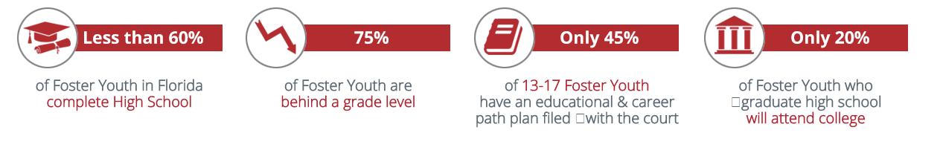

# User Story #668 -Content Filter

### Description:

* As a Content Manager/editor I want to review all content expected to be on the application so that all information presented on website/app are clear and relevant

### Acceptance Criteria:

1. All App/web pages are rich in content and has information presented in all appropriate pages
2. Information does not contain grammatical errors
3. Content presented are easy to read and has the approval of clients, and all Florida Reach Stakeholders( Partners, Colleges and Universities )

**Tasks**

* Review all materials/content expected to be on on website

**Use Case**

**N/A**

**Modeling**

**N/A**

# [#671](https://fiu-scis-seniorproject.mingle.thoughtworks.com/projects/apps__arts_and_issues__app_lyi/cards/671) Sometimes Campaign -Images/Graphic

### Description:

* As a graphic design I will develop snapshot so that it can expressed how the young person feel at some point in time

### Acceptance Criteria:

1. Visually appealing
2. simple and straight to the point
3. Campaign express one feeling
4. Picture must match feeling presented – words must matched
5. Diversity of Subject ( African American , Hispanics, White.. etc)

# [#674](https://fiu-scis-seniorproject.mingle.thoughtworks.com/projects/apps__arts_and_issues__app_lyi/cards/674) What Are You Reaching For -- Graphics

### Description:

* As a graphic design I will develop a visual graphic so that it can express how the youth reach for success

### Acceptance Criteria:

1. Visually appealing
2. simple and straight to the point
3. Campaign express one feeling
4. Picture must match feeling presented – words must matched
5. Diversity of Subject ( African American , Hispanics, White.. etc)

# [#672](https://fiu-scis-seniorproject.mingle.thoughtworks.com/projects/apps__arts_and_issues__app_lyi/cards/672) Capture " Sometimes " Images

### Description:

* As a communications student, I worked on an image campaign to get more college liaisons to join Florida Reach, as well as target young adults in foster care. This image campaign will create awareness.

### Acceptance Criteria:

1. Images need to include Florida Reach colors.
2. Images must correlate with the message.
3. Images must portray what Florida Reach is.
4. Images show real life scenarios that foster students face.
5. Image models must be of different backgrounds.

# [#667](https://fiu-scis-seniorproject.mingle.thoughtworks.com/projects/apps__arts_and_issues__app_lyi/cards/667) UI / Mockup Design for Florida Reach Mobile Application

### Description:

* As a graphic designer, I utilized Adobe Experience Design to develop website design template for Florida Reach
* Utilized Adobe Photoshop to create THINKivators logos and edit images for the website designs
* As a UI Designer I want to develop a complete mock up of the Florida Reach App so that the developers could utilize it for programming

### Acceptance Criteria:

1. Images are clear and understandable and capture Client vision
2. Mockup contains high quality visuals and images ,and content draft from documents Clients provided
3. Mockups are created in a cross-platform tool for designing and prototyping websites and mobile app another team members have the ability to utilize same software-i.e. Adobe Experience Design/ Photoshop..etc (PowerPoint is unacceptable)

### Sprint 2

# [#680](https://fiu-scis-seniorproject.mingle.thoughtworks.com/projects/apps__arts_and_issues__app_lyi/cards/680) Who We Are -Purpose Link

### Description:

* As the developer, I will gather links for “Purpose” page so that users can access and learn about the network

### Acceptance Criteria:

1. Consistent With Design /Florida Reach Colors
2. Detailed but not too long

# [#679](https://fiu-scis-seniorproject.mingle.thoughtworks.com/projects/apps__arts_and_issues__app_lyi/cards/679) Establish Links-Navigation

### Description:

* As a network member/interested party I want to have access to various pages through the navigation bar

### Acceptance Criteria:

1. Navigation Bar should be easily visible from the landing page
2. Titles of Navigation Bar should reflect contents of the page
3. Navigation Bar should be just as responsive as links on the actual page
4. Navigation Bar should follow the theme/color scheme of the rest of the page

# [#678](https://fiu-scis-seniorproject.mingle.thoughtworks.com/projects/apps__arts_and_issues__app_lyi/cards/678) Develop Carousel : Home Page

### Description:

* As a network member I want to see am image that reflects on the landing page so that I can understand through visuals what Positive Pathways is about

### Acceptance Criteria:

1. Contains three visually appealing graphic that summarizes Positive Pathways
2. Incorporates three motto/slogan to capture viewers attention
3. Must be the first feature that catches users attention upon entry on page

### Related Tasks:

1. Passes all regression test
2. passes all testing per acceptance criteria
3. Approve by UI Team
4. Ability to show Modal feature for Client demo

# [#670](https://fiu-scis-seniorproject.mingle.thoughtworks.com/projects/apps__arts_and_issues__app_lyi/cards/670) Develop THINKivator Logo

### Description:

* As a graphic design student, I developed a logo for the THINKivators, so that it can be use to represent our group.

### Acceptance Criteria:

1. Logos range from graphics to simple text typography.
2. Logo had to have a futuristic look.
3. Logo incorporate Slogan.
4. Logo has good work placement.

# [#673](https://fiu-scis-seniorproject.mingle.thoughtworks.com/projects/apps__arts_and_issues__app_lyi/cards/673) Florida Reach Because Campaign - Graphics

### Description:

* As a UI designer I will create the images for the FR because campaign so that it can be utilize for social media and website

### Acceptance Criteria:

1. With current Florida Reach members( Loraine , Steve, Brett, Virginia, Devin , Varzi )
2. Includes Short statements that highlight specific positive qualities of the Florida Reach Network
3. Must contain FR logo and “ Florida Reach Because..

# [#694](https://fiu-scis-seniorproject.mingle.thoughtworks.com/projects/apps__arts_and_issues__app_lyi/cards/694) Florida Reach Commercial

### Description:

* As a communication student, I created high-quality videos for Florida Reach “Sometimes” campaign. This videos showcase why college liaisons should become part of Florida Reach, as well as target young adults in foster care.

### Acceptance Criteria:

1. High-quality video
2. Message is clear
3. Florida Reach colors are visible in video
4. Approve by client, Steve Rios

# [#696](https://fiu-scis-seniorproject.mingle.thoughtworks.com/projects/apps__arts_and_issues__app_lyi/cards/696) Consent Form

### Description:

* As a communication student, I want create a consent form for Florida Reach image campaign so that the students give us permission to share their images

### Acceptance Criteria:

1. It’s very important to have models consent before using any images, without their permission.
2. Explained and informed models about Florida Reach how the images will be used.
3. Models must have read consent form and agree to participate.
4. Photograph young adults.

[**#697**](https://fiu-scis-seniorproject.mingle.thoughtworks.com/projects/apps__arts_and_issues__app_lyi/cards/697) **FLorida Reach Can Help**

### Description:

* As a communication major, I worked on images for Florida Reach social media post. The images included words, such as “Florida Reach Can Help.” Words can easily be read by the target audience.

### Acceptance Criteria:

1. clear message
2. readable
3. includes Florida Reach logo

### Sprint 3

# [#687](https://fiu-scis-seniorproject.mingle.thoughtworks.com/projects/apps__arts_and_issues__app_lyi/cards/687) Calendar Creation

### Description:

* As a Positive Pathway member /interested party I want to view calendar events so that I can stay inform and engage with positive Pathway

### Acceptance Criteria:

1. Calendar Must Display Month, day , Year
2. Acceptable in list for With title “ Upcoming Event”
3. Calendar must mark particular dates Positive Pathway events/ meeting occurring

# [#682](https://fiu-scis-seniorproject.mingle.thoughtworks.com/projects/apps__arts_and_issues__app_lyi/cards/682) Access Resources

### Description:

* As network member I want to view available resources Positive pathway have to offer through a page so that I can learn engage with Positive Pathways

### Acceptance Criteria:

1. Must contains a Professional Development, Podcast , and Modal
2. Button to access Microsoft Stream must be incorporated
3. Library Feature must be added

# [#683](https://fiu-scis-seniorproject.mingle.thoughtworks.com/projects/apps__arts_and_issues__app_lyi/cards/683) Programs List for School and Universities

### Description:

* As a network member/interested party I want to view different programs Positive pathway is connected with so that I can understand the Strong programs they have and the services they have to offer for at-risk and foster care youth

### Acceptance Criteria:

1. Programs must be the School with College coaches /Strong support program for Foster care youth
2. Programs description and services must be available on page
3. School logo is absolutely necessary

# [#685](https://fiu-scis-seniorproject.mingle.thoughtworks.com/projects/apps__arts_and_issues__app_lyi/cards/685) Learning Options

### Description:

* As a Network Member I want to listen to audio podcast and watch videos so that I can educate myself about different areas and subjects revolving at-risk /foster care Youth

### Acceptance Criteria:

1. Video player must be responsive (Pauses/Plays when prompted, full volume control)
2. Audio player must be responsive (Pauses/Plays when prompted, full volume control)
3. Video/Audio should be downloadable on the user’s device
4. Video player should have the capacity to upload from various sources (Youtube, user, etc.)

# [#700](https://fiu-scis-seniorproject.mingle.thoughtworks.com/projects/apps__arts_and_issues__app_lyi/cards/700) Upcoming Events Feature

### Description:

* As a Positive Pathway member /interested party I want to view upcoming events so that I can stay inform and engage with positive Pathway

### Acceptance Criteria:

1. Must be incorporated with Calendar must display month, day , year
2. Calendar Must display all major holidays: Christmas, Easter, President’s Day, Mother’s Day, Father’s Day, Labor Day, New Year’s Day.
3. Calendar must mark particular dates meeting , member orientation , Partner events

# [#690](https://fiu-scis-seniorproject.mingle.thoughtworks.com/projects/apps__arts_and_issues__app_lyi/cards/690) Newsletter Module

### Description:

* As a Network member/interested party I want to view the latest news going with Positive Pathway so that I can stay Connected

### Acceptance Criteria:

1. News Letter must always have the proper date
2. Articles in news letter must be relevant to occurrences in the network/community
3. Links in news articles must be responsive
4. News Letter must be visually appealing and contain images, graphics, and match Florida Reach/Positive Pathway colors

# [#692](https://fiu-scis-seniorproject.mingle.thoughtworks.com/projects/apps__arts_and_issues__app_lyi/cards/692) Subscribe Opt In/Sign Up

### Description:

* AS a network member or interested party I want the option to subscribe to Newsletters so that I can stay engage with Positive Pathway

### Acceptance Criteria:

1. Check box for subscription must be easily visible to the user
2. Opt in should either be a pop-up or a button on the landing page
3. Must automatically add a user’s email to the mailing list (Next Iteration)

# [#691](https://fiu-scis-seniorproject.mingle.thoughtworks.com/projects/apps__arts_and_issues__app_lyi/cards/691) Social Media Access

### Description:

* As a 3P Network member I want to access positive Pathway social Media pages so that I can stay engage and in the loops with the happenings of Positive Pathway

### Acceptance Criteria:

1. Social media links must be responsive and properly connect users to their social media accounts
2. Social media links must use respective social media network logos/colors for easy recognition
3. Links must not cause a nuisance on user’s social media accounts (Spamming timelines/friend’s timelines)

# [#695](https://fiu-scis-seniorproject.mingle.thoughtworks.com/projects/apps__arts_and_issues__app_lyi/cards/695) Forida Reach Social Media Calendar

### Description:

* As a Florida Reach Network member, I want to access a calendar so that I can view the latest news and events.

### Acceptance Criteria:

1. Calendar must be continuously accurate
2. Calendar must be easily editable to reflect real life changes
3. Calendar events should link to information pages relevant to said event

### Sprint 4

# [#688](https://fiu-scis-seniorproject.mingle.thoughtworks.com/projects/apps__arts_and_issues__app_lyi/cards/688) Documents Access

### Description:

* As Positive Pathway member I want to access various documents so that I can learn, shared and educate people about Florida Reach

### Acceptance Criteria:

1. Through the research page Member Must have the ability to locate various documents ( PDF, Words, JPG, GIF, ETC)
2. Documents must be displayed as a clickable link
3. All documents must be located under “Library” section

# [#681](https://fiu-scis-seniorproject.mingle.thoughtworks.com/projects/apps__arts_and_issues__app_lyi/cards/681) People In Network Table

### Description:

* As a web User (Positive pathway network member/interested party) I want to search for different people in the network through a table so that I can easily connect and learn about what they do

### Acceptance Criteria:

1. Must be able to navigate table with scroll bar
2. Table options must be responsive
3. Must be able to sort and filter by Name, Network, Location/City
4. Once a name has been searched, must condense table to one result/highlight one result

# [#684](https://fiu-scis-seniorproject.mingle.thoughtworks.com/projects/apps__arts_and_issues__app_lyi/cards/684) Join Now Button/Form

### Description:

* As a Educator or professional interested in joining the Positive pathway network. I would like the ability to fill out a brief form so that I can be contacted to be added to the Positive Pathway Network

### Acceptance Criteria:

1. Join Now button must be easily accessible
2. Form must accurately record and send data from text fields
3. Form must not be able to submit unless all required information is inputted
4. Fields “Name”, “Email”, “Network of Interest”, and “Details” should be required

# [#689](https://fiu-scis-seniorproject.mingle.thoughtworks.com/projects/apps__arts_and_issues__app_lyi/cards/689) Filter Feature for Table

### Description:

* As a network member/interested party I want to filter and search for people belonging to the different networks by different options and categories so that I can easily pull up their BIO and learn about them

### Acceptance Criteria:

1. User must have the ability to search by various Criteria Name (First, last ), Organization, Location, Network
2. Autocomplete complete enable to assist user with finding Network member
3. Search Bar located “Top Left” of table directory with network member listing

# [#693](https://fiu-scis-seniorproject.mingle.thoughtworks.com/projects/apps__arts_and_issues__app_lyi/cards/693) Network Member BIO Modal

### Description:

* As a network Member/Interested party I want to have the ability to read a brief Bio about other network members so that I can see how they can help me and vice versa

### Acceptance Criteria:

1. Contains their name and job title at on top header and brief Biography to explain work experience
2. Display contact information to the left of BIO: Fields include Email and phone number
3. Display a clear , qualify image of each member

### Related Tasks:

1. Passes all regression test
2. passes all testing per acceptance criteria
3. Approve by UI Team
4. Ability to show Modal feature for Client demo

### Sprint 5

# [#675](https://fiu-scis-seniorproject.mingle.thoughtworks.com/projects/apps__arts_and_issues__app_lyi/cards/675) Newsletter Design for Website/App

### Description:

* As a Graphic Designer I will develop the design for the FR Newsletter so that it is engaging and to be use to inform the FR network of what is going on

### Acceptance Criteria:

1. Develop Catchy name , for Example “ Florida Reach Quick Look”
2. Has the following sections – Lead story, latest news from F.R. , New Member Section,
3. Visually appealing -Make different /Unique page

[**#686**](https://fiu-scis-seniorproject.mingle.thoughtworks.com/projects/apps__arts_and_issues__app_lyi/cards/686) **Contact Us Form**

### Description:

* As a Florida Reach member I want to have the ability to reach out to the Steering Team of positive pathway so that my questions and concerns can be answered

### Acceptance Criteria:

1. Form must capture senders information in text fields
2. Fields : Your Name(Required), Your Email( Required), Subject, Your Message
3. A user cannot submit the form without completing all the mandatory field
4. An acknowledgment message appear to the user after submitting the form

# [#676](https://fiu-scis-seniorproject.mingle.thoughtworks.com/projects/apps__arts_and_issues__app_lyi/cards/676) Develop Privacy Policy - Florida Reach

### Description:

* As a developer I will develop a privacy policy for FR so that it can be used for the app store/ website

### Acceptance Criteria:

1. Address FR information collection, Opt-out, use of information and other sections
2. Contains no grammatical error and has been reviewed by Clients
3. Up to date and meet platform Guideline

# System Design

This section contains information on the design decisions that went into this project. The architecture patterns are outlined and explained. The entire system is shown in a package diagram and the subsystems are explained. Finally, the design patterns used in the project are discussed.

## Architectural Patterns

The positive Pathway website version 1.0 Used the Model-View-Controller (MVC) architecture.

The goal is to eventually design the Positive Pathway website system so it could have several tiers. Version 2.0 of the website will contain a database tier where the application data will be hosted. Different features of the website that will access the website such as the People table will be located in this tier once it is develop.The Network members will function at the user tier.

The MVC architectural pattern is located in the application tier .This application consist of three different components: Model, View, and Controller. Once Version 2 of the website is developed with the database system data, logic, and the rules pertaining to the Positive Pathway Website will be located in the Model Layer. What the user sees will be displayed in the View layer. In features such as the Join Now , Subscribe and Contact Us network members will be inputting data that will be accepted, it is here the controller layer begin the process to transition to Model and View layer of the MVC architectural pattern.

## System and Subsystem Decomposition

The Positive Pathway front end system consist of primarily three main components:Services , Templates and Controllers . These three components are what the frontend of the web application are made of. Upon development of the backend database, the services will be where the front end communicates to the backend server , there will exist the ability to request data to appear to the network users.The template component where the markup language will be used to describe the organization of the content.Furthermore, the template elements are bound using data-binding in Angular CLI . A further look into the template will reveal how styles works for CSS when styling websites. Additionally, logic and functionality of the applications are as a result of the controllers component.

## Deployment Diagram

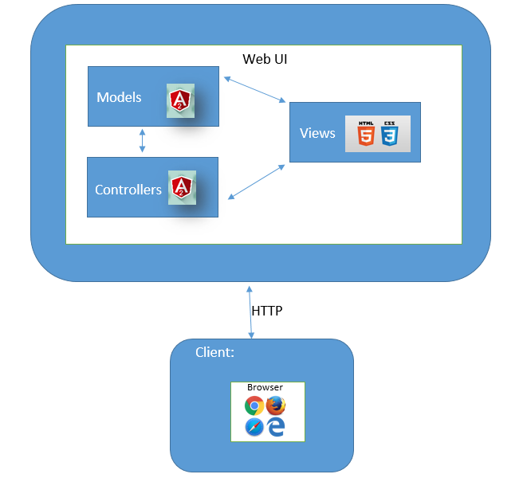

## Design Patterns

**Factory Pattern:** The positive pathways website uses Angular CLI on the frontend. Specific measures were taken to ensure the objects were represented appropriately and other actions correlated with each other, As a result, the controllers had the ability access these factory-created service only when necessary and assisted codebase to remain modularity. For instance, many modals are used in the Positive Pathways system. Instead of implementing a modal system within each controller, we build a factory that returns an instance of a modal component related to what the controller need. This was very beneficial because it only required one change to be made when we had to make changes in the system instead of multiple occurrences.

# System Validation

|  |
| --- |
| **Test ID: PPP_Setup** |
| **Purpose:**  To test that the Positive Pathways website is functioning on the my local server. |
| **Preconditions:**  Angular is running. |
| **Input:**  Navigate to [http://localhost:4200](http://localhost:3000/) |
| **Expected Output:**  The web page is displayed |

# 

|  |
| --- |
| **Test ID: PPP_Search_1** |
| **Purpose:**  Search for people in the network |
| **Preconditions:**  User should see the table with people  User should be able to navigate the table and open any person’s bio. |
| **Input:**  User click on any person in the table |
| **Expected Output:**  Display the information of the person selected |

# 

|  |
| --- |
| **Test ID: PPP_Search_2** |
| **Purpose:**  Search for people in the table through a search bar |
| **Preconditions:**  User should click on the Search bar of the table |
| **Input:**  User should see the result of the filtered search in the table  User should be able to click on the result and see the person’s bio. |
| **Expected Output:**  Display the information of the person selected |

# 

|  |
| --- |
| **Test ID: PPP_Links** |
| **Purpose:**  To verify that every link in the website works correctly |
| **Preconditions:**  The user should be able to see any link  The user should be able to identify the purpose of the links |
| **Input:**  The user should be able to click any link |
| **Expected Output:**  A new page is open in a new tab with the website address linked to the reference |

# 

# Glossary

**Positive Pathways Program:**

**3P/Network Member:** Post-secondary educational campus coaches, designated by their educational or community service institution, with either part-time or full-time responsibilities.

**MVC**: Model, view, controller architecture design paradigm

**Florida Reach:** The mission of Florida Reach is to improve post-secondary outcomes and career transitions for foster care youth and alumni through support, resources, networking and determining collective impact.

**Department of Children and Families:**Community Connection to Economic Self Sufficiency (ACCESS).

# Appendix

## Appendix A - UML Diagrams

## Capture.PNG

## Capture1.PNG

## Appendix B - User Interface Design

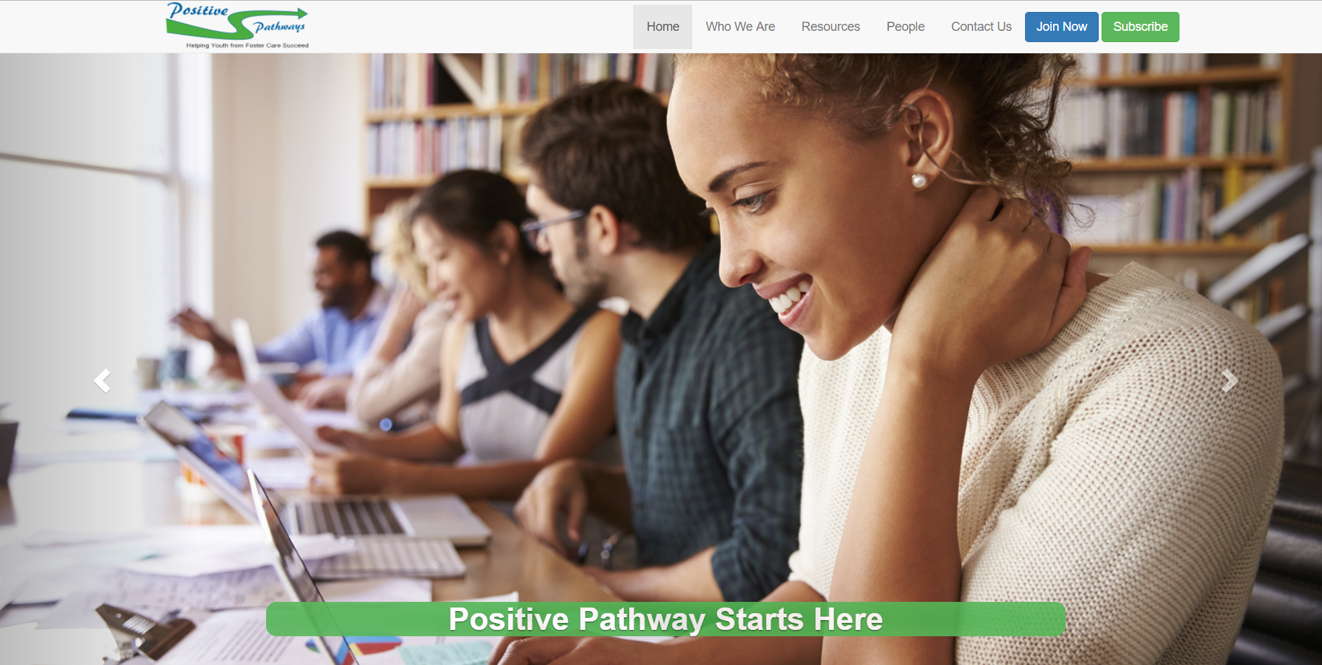

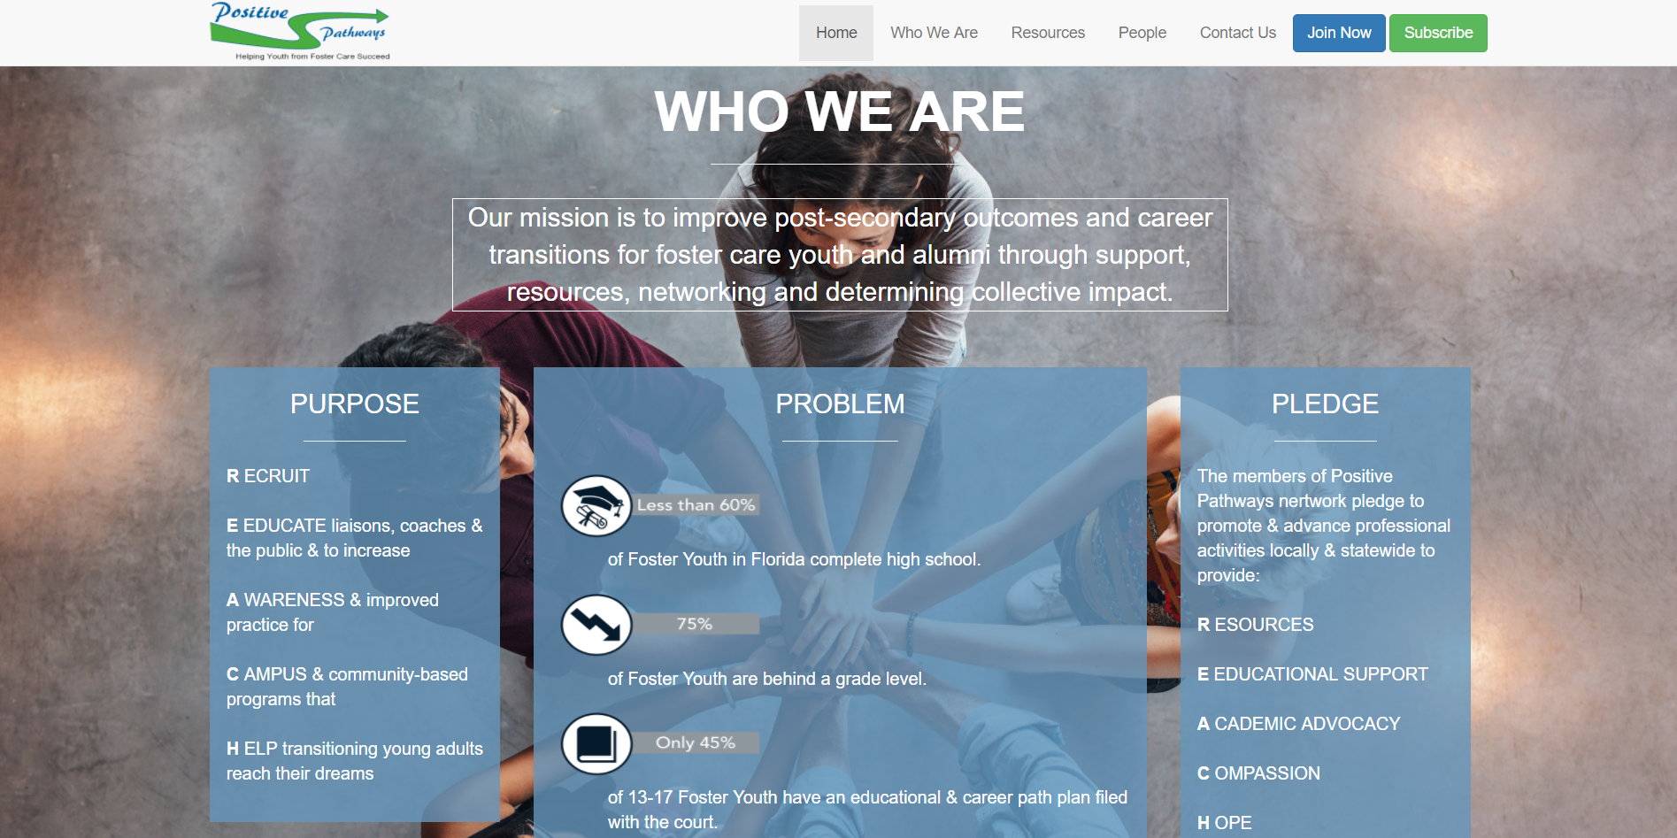

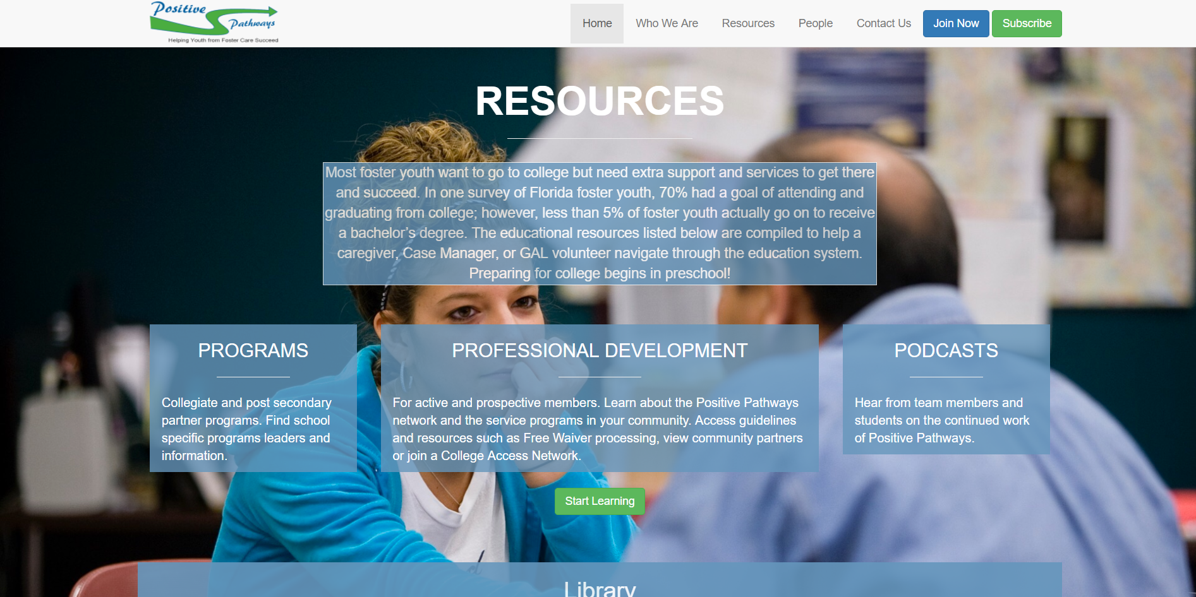

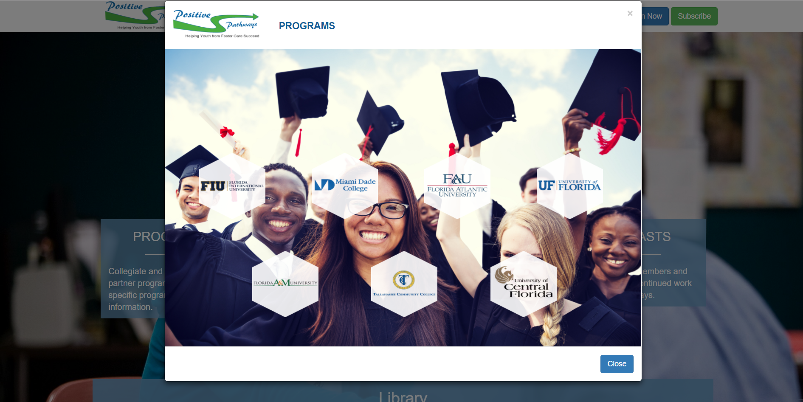

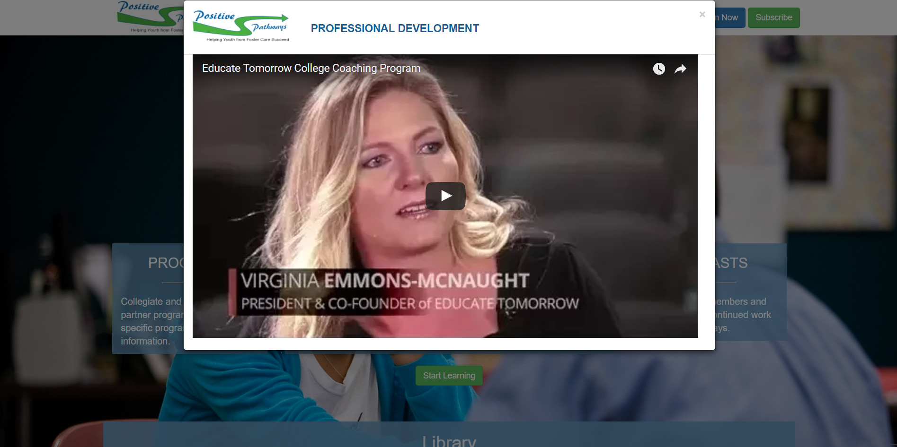

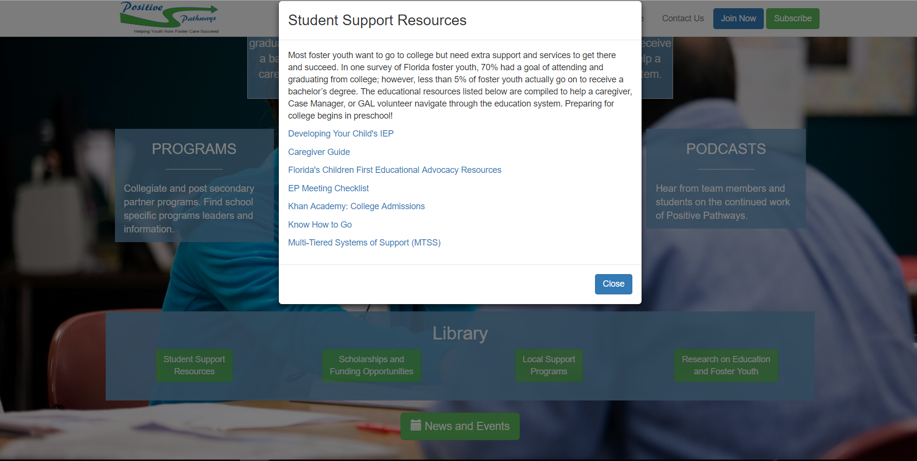

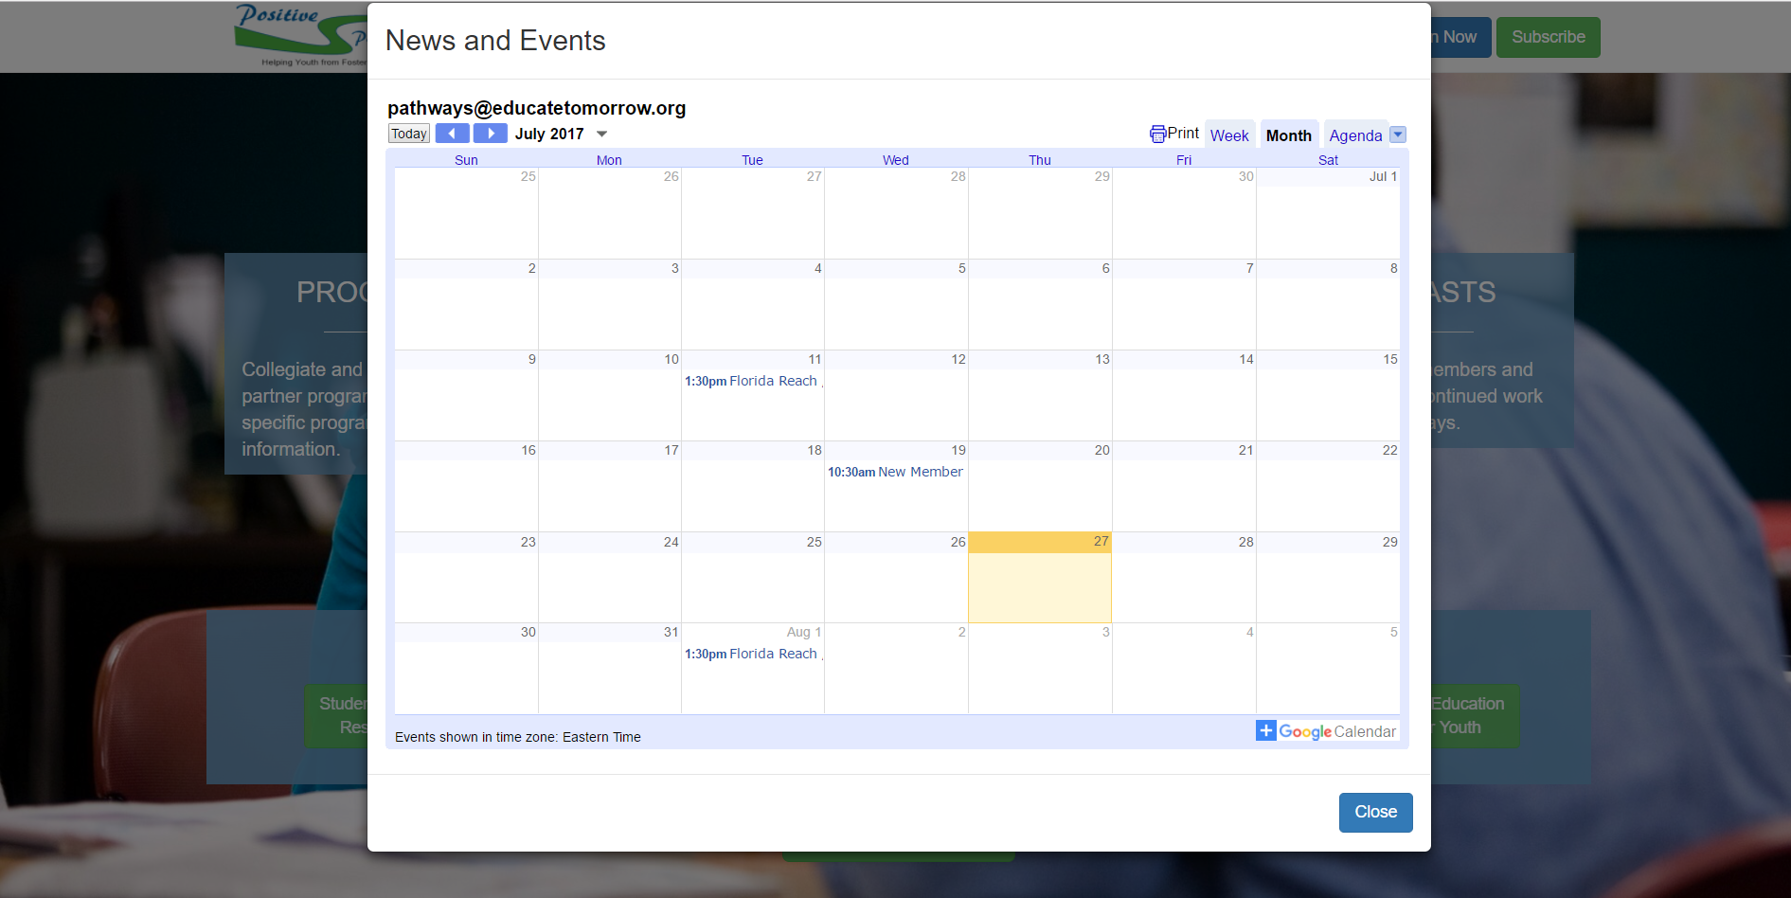

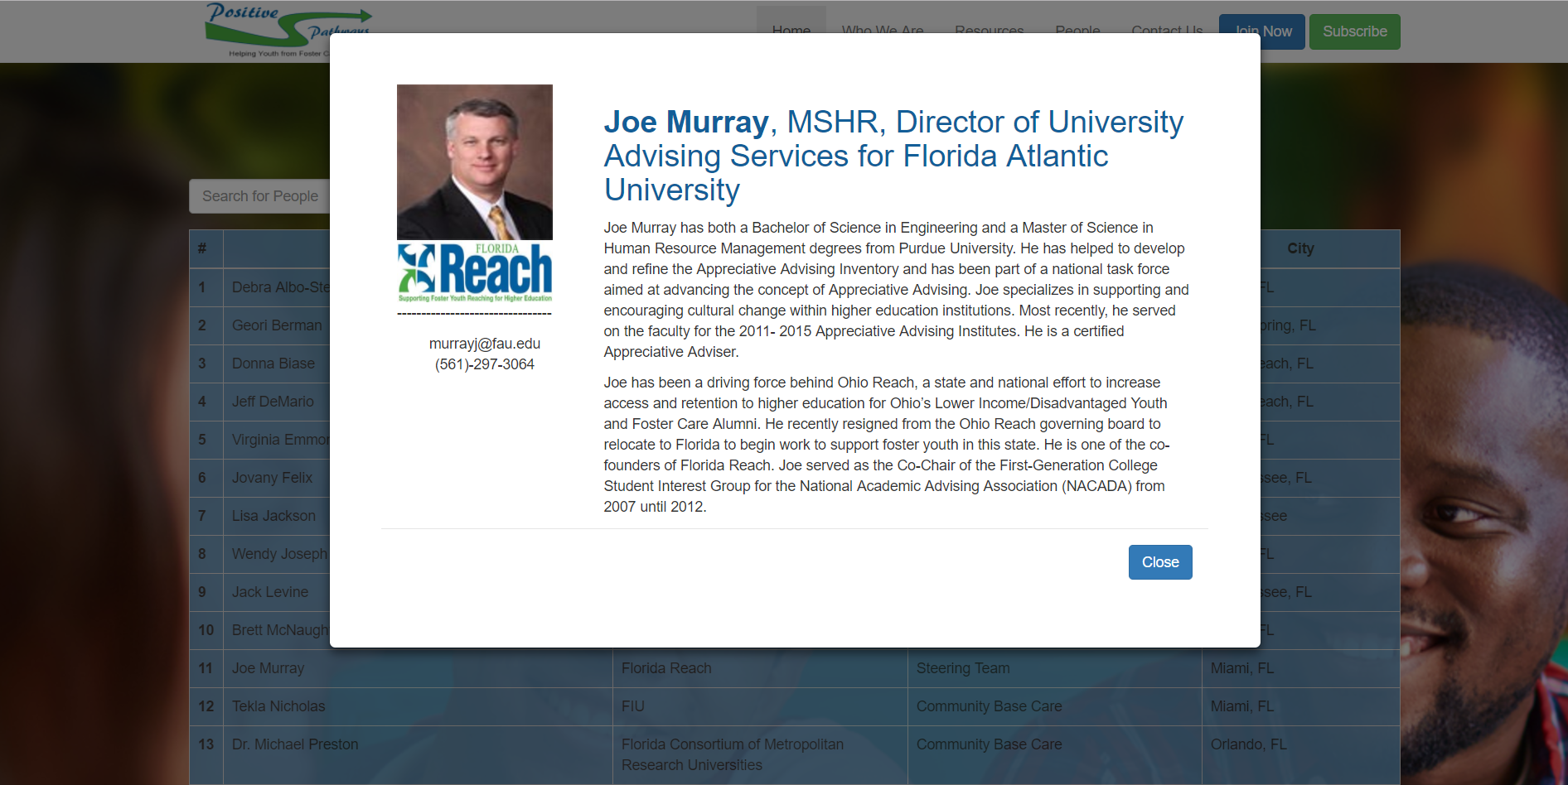

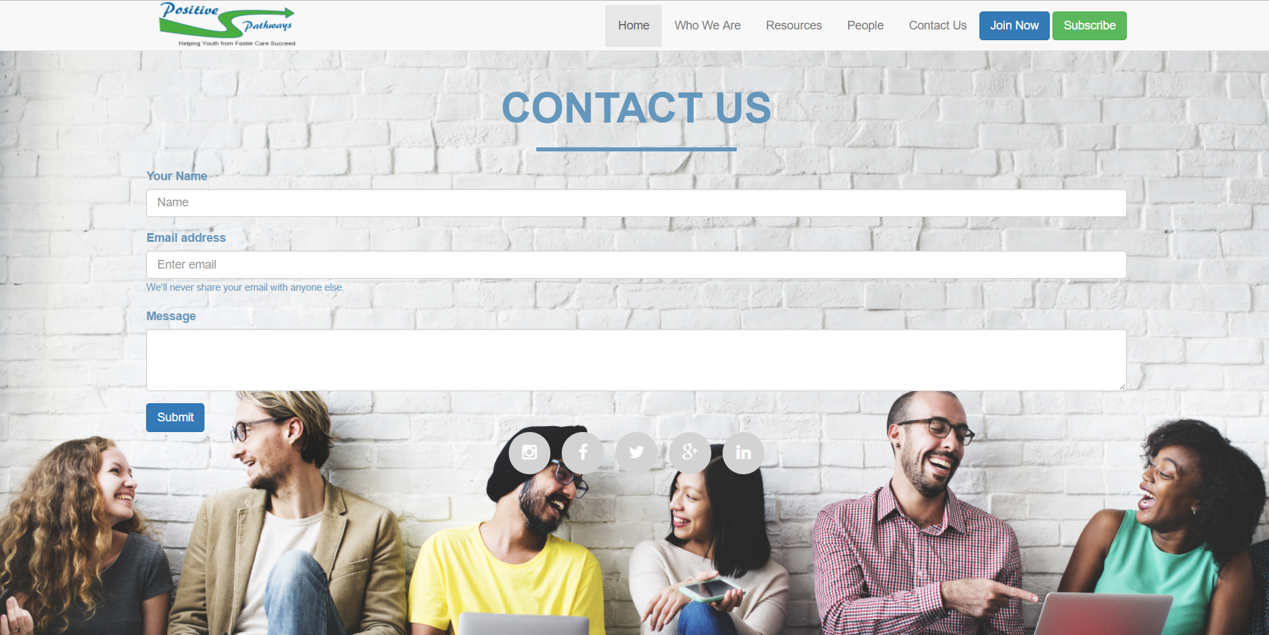

## 

## 

## Appendix C - Sprint Review Reports

**Sprint 1 Review Meeting Minutes :06/03/2017**

Attendees: Claudia Gourdet, Ranses Melo, Jose Ayala, Derek Hernandez, Enrique Hidalgo, Mariel Juarez, Nathalie Llaneza,Dr.Steve Rios, Margo Berman

Start time: 4:00 PM

End time: 6:00 PM

After a show and tell presentation, the implementation of the following user stories were accepted by the product owners: All.

# [User Story #677](https://fiu-scis-seniorproject.mingle.thoughtworks.com/projects/apps__arts_and_issues__app_lyi/cards/677) Navigation Bar

# [Story #663](https://fiu-scis-seniorproject.mingle.thoughtworks.com/projects/apps__arts_and_issues__app_lyi/cards/663) Florida Reach STAT- Graphic

# User Story [#667](https://fiu-scis-seniorproject.mingle.thoughtworks.com/projects/apps__arts_and_issues__app_lyi/cards/667) UI / Mockup Design for Florida Reach Mobile Application

The following ones were rejected and moved back to the product backlog to be assigned to a future sprint at a future Spring Planning meeting.

* No implementations were rejected.

**Sprint 2 Review Meeting Minutes :6/17/2017**

Attendees: Claudia Gourdet, Ranses Melo, Jose Ayala, Derek Hernandez, Enrique Hidalgo, Mariel Juarez, Nathalie Llaneza,Dr.Steve Rios, Margo Berman

Start time: 4:00 PM

End time: 6:00 PM

After a show and tell presentation, the implementation of the following user stories were accepted by the product owners: All.

# [Story #679](https://fiu-scis-seniorproject.mingle.thoughtworks.com/projects/apps__arts_and_issues__app_lyi/cards/679) Establish Links-Navigation

* [User Story #678](https://fiu-scis-seniorproject.mingle.thoughtworks.com/projects/apps__arts_and_issues__app_lyi/cards/678) Develop Carousel : Home Page

# [User Story #699](https://fiu-scis-seniorproject.mingle.thoughtworks.com/projects/apps__arts_and_issues__app_lyi/cards/699) Develop THINKivator Logo

# [User Story #694](https://fiu-scis-seniorproject.mingle.thoughtworks.com/projects/apps__arts_and_issues__app_lyi/cards/694) Florida Reach Commercial

# [User Story #697](https://fiu-scis-seniorproject.mingle.thoughtworks.com/projects/apps__arts_and_issues__app_lyi/cards/697) Florida Reach Can Help

The following ones were rejected and moved back to the product backlog to be assigned to a future sprint at a future Spring Planning meeting.

* No implementations were rejected.

**Sprint 3 Review Meeting Minutes:07/03/2017**

Attendees: Claudia Gourdet, Ranses Melo, Jose Ayala, Derek Hernandez, Enrique Hidalgo, Mariel Juarez, Nathalie Llaneza,Dr.Steve Rios, Margo Berman

Start time: 3:00 PM

End time: 4:00 PM

After a show and tell presentation, the implementation of the following user stories were accepted by the product owners: All.

# [User Story #682](https://fiu-scis-seniorproject.mingle.thoughtworks.com/projects/apps__arts_and_issues__app_lyi/cards/682) Access Resources

* [#683](https://fiu-scis-seniorproject.mingle.thoughtworks.com/projects/apps__arts_and_issues__app_lyi/cards/683) Programs List for School and Universities

# [#685](https://fiu-scis-seniorproject.mingle.thoughtworks.com/projects/apps__arts_and_issues__app_lyi/cards/685) Learning Options

# [#687](https://fiu-scis-seniorproject.mingle.thoughtworks.com/projects/apps__arts_and_issues__app_lyi/cards/687) Calendar Creation

# [#700](https://fiu-scis-seniorproject.mingle.thoughtworks.com/projects/apps__arts_and_issues__app_lyi/cards/700) Upcoming Events Feature

# [#690](https://fiu-scis-seniorproject.mingle.thoughtworks.com/projects/apps__arts_and_issues__app_lyi/cards/690) Newsletter Module

# [#692](https://fiu-scis-seniorproject.mingle.thoughtworks.com/projects/apps__arts_and_issues__app_lyi/cards/692) Subscribe Opt In/Sign Up

# [#691](https://fiu-scis-seniorproject.mingle.thoughtworks.com/projects/apps__arts_and_issues__app_lyi/cards/691) Social Media Access

The following ones were rejected and moved back to the product backlog to be assigned to a future sprint at a future Spring Planning meeting.

* No implementations were rejected.

**Sprint 4 Review Meeting Minutes:07/17/2017**

Attendees: Claudia Gourdet, Ranses Melo, Jose Ayala, Derek Hernandez, Enrique Hidalgo, Mariel Juarez, Nathalie Llaneza,Dr.Steve Rios, Margo Berman

Start time: 4:00 PM

End time: 6:00 PM

After a show and tell presentation, the implementation of the following user stories were accepted by the product owners: All.

# [#688](https://fiu-scis-seniorproject.mingle.thoughtworks.com/projects/apps__arts_and_issues__app_lyi/cards/688) Documents Access

# [#681](https://fiu-scis-seniorproject.mingle.thoughtworks.com/projects/apps__arts_and_issues__app_lyi/cards/681) People In Network Table

# [#689](https://fiu-scis-seniorproject.mingle.thoughtworks.com/projects/apps__arts_and_issues__app_lyi/cards/689) Filter Feature for Table

* [#693](https://fiu-scis-seniorproject.mingle.thoughtworks.com/projects/apps__arts_and_issues__app_lyi/cards/693) Network Member BIO Modal

The following ones were rejected and moved back to the product backlog to be assigned to a future sprint at a future Spring Planning meeting.

* No implementations were rejected.

**Sprint 5 Review Meeting Minutes: 07/27/2017**

Attendees: Claudia Gourdet, Ranses Melo, Jose Ayala, Derek Hernandez, Enrique Hidalgo, Mariel Juarez, Nathalie Llaneza,Dr.Steve Rios, Margo Berman

Start time: 4:00 PM

End time: 6:00 PM

After a show and tell presentation, the implementation of the following user stories were accepted by the product owners: All.

# [#675](https://fiu-scis-seniorproject.mingle.thoughtworks.com/projects/apps__arts_and_issues__app_lyi/cards/675) Newsletter Design for Website/App

# [#686](https://fiu-scis-seniorproject.mingle.thoughtworks.com/projects/apps__arts_and_issues__app_lyi/cards/686) Contact Us Form

# [#676](https://fiu-scis-seniorproject.mingle.thoughtworks.com/projects/apps__arts_and_issues__app_lyi/cards/676) Develop Privacy Policy - Florida Reach

The following ones were rejected and moved back to the product backlog to be assigned to a future sprint at a future Spring Planning meeting.

* No implementations were rejected.

## Appendix D - Shortcomings/Wishlist Document

## Shortcomings/Wishlist

We worked on version 1.0 of The Positive Pathways Program website and developed social media platforms and several campaigns to raise awareness for Positive Pathways. We were able to develop a functional website with features and components to support the network members.However, there were some desired features that were left unimplemented. As well as additional components needed to enhance the website and further develop it.

In future iterations of the Positive Pathways website the client would like to see the following additions and improvements.

* Database
* Positive Pathways Program logo
* Android/ iphone mobile application
* Login Feature whether it be through Gmail/Facebook
* Professional Development training hosted on the website

The table below highlight in which sprint the features is recommended to be implemented.

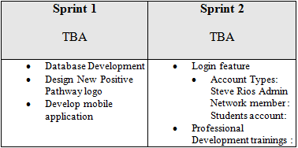

# References

Toirac, Facelift Designs: Jose L. "Educate Tomorrow." *Educate Tomorrow*. Educate Tomorrow, 15 Oct. 2017. Web. 28 July 2017.

"About." *About | Florida Department of Children and Families*. Department of Children and Families, 31 July 1970. Web. 28 July 2017.

Rios, Steve. "Rios Research & Evaluation." *Rios Research & Evaluation*. N.p., n.d. Web. 28 July 2017.